# Project Presentation

The Goal Of This Project Was To Implement A Dialogue System For Controlling A Robot Living In A Virtual Block World. The Robot Can Move Around Objects Of Different Forms, Colors And Sizes, And It Can Answer Questions About The World And Ask For Clarification Whenever It Finds Request Ambiguous.

This Has Been Performed Using Grammaticalframework (Gf) For The Grammar And Java/Prolog For The Implementation. The World Is Described Using A Json File.

# The World

The World Is Represented By A Floor On Which Several Objects (Of Different Forms, Colors And Sizes) Can Lay. The Objects Can Stand In/On Each Other (If It Is Permitted By The World’s Laws).

The Goal Of This Project Is To Move Around The Objects, According To The Request Of The User, Through A Robot Arm Which Can Pick Up And Put Down Objects.

The Floor Is Divided In N Spaces, Meaning That There Is Room On The Floor For No More Than N Objects At The Same Time. Each Of This Space Is Represented Has A Column, So That The World Can Be Describe As A List Of N Columns Of Objects Stake On Each Other.

The World We Implemented Can Contain All The Objects Of Different Forms, Colors And Sizes Listed On The Course Homepage, Plus The Possibility To Define An Object Of Medium Size (In Order To Create A More Complex/Realistic World).

Bellow The List Of Forms, Colors And Sizes Available In “Our” World:

Forms: Bricks, Planks, Balls, Pyramids, Boxes And Tables.

Colors: Red, Black, Blue, Green, Yellow, White.

Sizes: Large, Medium, Small.

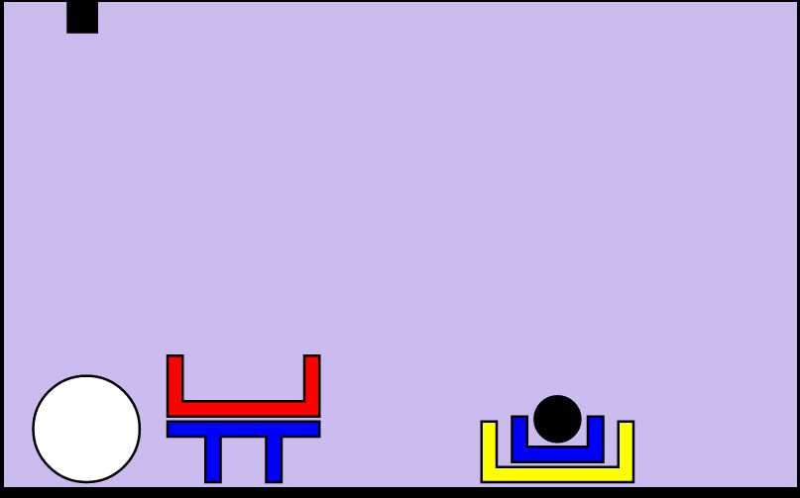

This World Is Described Using A Json File Describing The World As A List Of Columns Of Objects.

# Grammar

We started with the initial grammar (given at the beginning of the project) that we have completed and improved.

The major improvements we implemented are the possibility for the user to ask 3 new types of questions: where, what and count.

Where:

The “where” question allow the robot to answer questions such as “where is the white big ball?” Or “where are the boxes?”. The synonym for the “where” questions are the words:

* Find
* Where is
* Where are

What:

With this “what” question, the robot can answer questions such as “what is under the red box?” Or “what are the object in the world?”. The synonym for the “what” questions are the words:

* What is
* What are

Count:

This last new possible question aim to permit the user to get answer to requests such as “count the boxes in the world.” or “how many ball are in the world?”. The synonyms for the “count” questions are:

* Count
* How many

Another major improvement we made from the original grammar is the possibility for the user to request actions and/or ask questions about stack instead of simply the whole world. The user can then perform request like “what are the objects in stack 2?” Or “count the small blue balls in stack 0.” Or “what are the objects on the right of stack 2?”

We also added 2 minor improvements to the original grammar: the alias “world” for “all the stacks” and the possibility for the user to put question marks at the end of his questions without having the robot answering with an error message.

Of course all those modifications regarding the grammar had to be echoed to the other layers of the application (parser and planner).

# Interpreter

After the grammar layer we then proceed to the interpreter layer.

For starters we have a world like [[a,b],[c]...], where the letters correspond to some element defined according the world’s rules on forms, colors and size. Those Objects are of the form:

Objects = json([a = json([Type,Size,Color]),...]

In order to query an object of defined form, size and color we created the following function:

getobj([anyform,-,-],PossibleObjects,SelectedObject) :-  
    member(SelectedObject=json([form=_,size=_,color=_]), PossibleObjects).

where PossibleObjects is a list from which we want to query and of the same form as Objects.

Then to get the element, we need to make sure that SelectedObject is satisfying the form, size and colour of the world and is a member of  PossibleObjects.  
  
Further we implemented some functions to check if, for example, an object is besides any other object:  
isbeside(X,Y,World) :-  
    member(ColS,World),member(X,ColS), nth0(IdxS,World,ColS),  
    member(ColR,World),member(Y,ColR), nth0(IdxR,World,ColR),  
    (IdxS is IdxR-1;IdxS is IdxR+1).  
  
When we want a Goal for a given tree we use the following function:  
interpret(move(X,relative(beside, Y)), World, Holding, Objects, movebeside(SelectedObject,RelativeObject)) :-  
    interpret(X, World, Holding, Objects, SelectedObjectTAA),  
    interpret(Y, World, Holding, Objects, RelativeObjectTAA),  
    handleQuantifiers(SelectedObjectTAA, RelativeObjectTAA, SelectedObject, RelativeObject).  
  
this is recursive but the output is for e.g. SelectedObjectTAA is assumend to be of the form [a,b,..] or any([a,b,..])  
handeQuantifiers uses cuts to choose one possible action.. e.g. (without handling -> handling)  
movebeside([a,b],[c,d]) -> movebeside([a,b],[c,d])  
movebeside(any([a,b]),any([c,d])) -> movebeside([a],[c])  
movebeside([a,b],any([c,d])) -> movebeside([a,b],[c]))  
movebeside(any([a,b]),[c,d]) -> movebeside([a],[c,d])  
  
  
  
If we look at this rule  
interpret(relative(above,X), World, Holding, Objects, SelectedObject) :-  
    interpret(X, World, Holding, Objects, RelativeObjectTAA), (any(RelativeObject) = RelativeObjectTAA ; RelativeObject = RelativeObjectTAA),  
    findall(SelectedObjectAux,  
    (member(RelativeObjectAux, RelativeObject), isabove(SelectedObjectAux,RelativeObjectAux,World)),  
    SelectedObject),SelectedObject \== [].  
  
  
if get RelativeObjectTAA which is of the form [a,b..] or any([a,b..])  
here we don't really care about any (it's handled elsewhere) so we simply extract  
the list to RelaiveObject. we the find all objects satisfying the relation.  isabove can return a list so we need to check every member of that to check relations. empty lists satisy the relation as well, so we disregard those.  
  
  
the rule e.g.  
interpret(relative_entity(any,X, Relation), World, Holding, Objects, any(SelectedObject)) :-  
    findall(RelativeObjectAux, ( interpret(Relation, World, Holding, Objects, RelativeObjectListAuxAux),  
                                 member(RelativeObjectAux, RelativeObjectListAuxAux)),  
                                RelativeObjectListAux),  
    sort(RelativeObjectListAux,RelativeObjectList),  
    %Find all objects which supports the relation  
    findall(SelectedObjectAux,( member(SelectedObjectAux, RelativeObjectList),  
                                interpret(X,        World, Holding, Objects, SelectedObjectAux)),  
                                SelectedObject).  
  
is simply collecting all objects satisfying a relation, we first fin all possible objects satisfying the relation, then sort the list to remove duplicates and then find all objects satisfying the description as well as being a member of the relation satisfactions.  
these rules are quite similar for "all" and "any", but we modify the return to act as a flag.  
  
  
last example  
interpret(object(Type,Size,Color), World, Holding, Objects, SelectedObject) :-  
json(AllPossibleObjects) = Objects,  
findall(X=json([A,B,C]), (member(Col,World),member(X=json([A,B,C]),AllPossibleObjects),member(X,Col)), PossibleWorldObjects),  
member(Holding = json([A1,A2,A3]),AllPossibleObjects),  
append(PossibleWorldObjects,[Holding = json([A1,A2,A3])],PossibleObjects),  
getobj([Type,Size,Color], PossibleObjects, SelectedObject).  
  
this will return the letter of queried object  
what we do is to extract the objects in a more manageable form, append what the arm is holding, and lastly "get" the objects from the possible objects.

# Planner

# Ambiguities handling

The ambiguities handling allow the robot to handle cases where the request from the user is not clear enough. For example, in picture 1, “what is under the box?” would lead to an ambiguity, since the robot would not know if the user want to know what is under the red box or the blue box or the yellow box.

In case of ambiguity, the robot ask the user for a precision. The user then has to precise the object he is referring to. In our example, it could be “the small blue box”.

Once the user has precise the object, the robot will get this information and try to match with all the possible goal he has identified. It then select the unique matching solution (if it exists).

If an ambiguity still occurs the robot then return an error. There is no second question ask to the user since prolog does not handle while loop.